FULL NAME: Akashdeep singh

STUDENT ID:100415028

EMAIL ID: akashdeepsingh11@email.kpu.ca

website url:

<https://sites.google.com/view/systemanalysis2021s10/home>

INTRODUCTION:

The "Online Vegetable Store" was created to address the shortcomings of the traditional manual approach. This programme is designed to remove or, in some circumstances, mitigate the difficulties that this system now faces. Furthermore, this system is tailored to the company's specific requirements for smooth and efficient operations. Their information and management systems are critical for collaborating with and influencing suppliers. On the other side, marketing and other methods are critical in understanding client demand.

The project's key feature is that it allows administrators to manage the records of Shops and their Vegetable Shops, including Vegetable Sales, Vegetable Stocks, and Vegetable Sales History. Other elements of the Vegetable Shop Management System include the requirement for the user to supply Vegetable name, Vegetable price, and Vegetable quantity when adding goods from the admin account.

Similarly, while replenishing Vegetables, the user must first pick the Vegetable by entering its name, and then input the amount. Removing a Vegetable is likewise a piece of cake; all he needs to do is open the report and select the remove Vegetable option. While examining stocks, the system provides Particulars (Vegetable name) along with Available stock and Price.

The goal of the project is to develop a system that allows customers to book vegetables from a certain store using precise information. So that there is no squandering of time.

Because they are the ultimate point of contact for customers, retailers and their related services play a crucial role in the supply chain. Retailers are the final link in the supply chain, as they are in direct touch with the end users. This is the most important link because it is the customer's final opportunity for purchasing products.

INTERFACE PROTOTYPE:

REVIEW CLASS DIAGRAM:

Vegetable Store Management System Types Diagram of a Class:

• Vegetable Class: Manage all Vegetable activities.

• Store Class: Manage all Store operations.

• Stock Class: Manage all Stock operations.

• Category Class: Manage all Category operations.

• Payment Class: Manage all Payment operations.

• Bill Class: Oversee all of Bill's operations.

Relational database tables:

Customer details:-

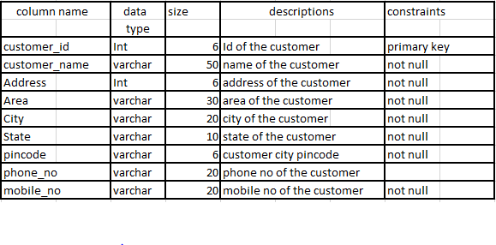

Work experience:

Working in team is really a fun and amazing experience. Everyone cooperate and coordinates with each other. All the team member understand each other and help to solve their problems.